EXPERIMENT-2
NAME: Yuvaraj A ROLL NO:240701809
Design a UI where users recall visual elements (e.g., icons or text chunks). Evaluate the effect of chunking on user memory.

FRAME 1: INSTRUCTION PAGE

Chunking Analysis of the Instruction Page
Chunking is a cognitive technique that organizes information into smaller, meaningful units to improve understanding and memory performance. The instruction screen of the Train Your
Visual Memory interface effectively applies chunking through the following design elements:

1. Structured Numbered Steps
- The instructions are divided into six clearly numbered sections, each representing a single concept.
- Each step communicates one specific idea, reducing cognitive load and making the information easier to process.
- The sequential flow helps users quickly understand the task without confusion.

2. Functional Grouping of Information
- The instructions are logically organized into meaningful phases:
- Attention Phase (Steps 1–2)
Users are guided to observe carefully and understand that emojis appear in grouped patterns.
- Time Awareness (Step 3)
The limited viewing time prepares users for focused attention.
- Memory Strategy (Step 4)
Users are encouraged to remember visual patterns rather than individual items.
- Task Constraint (Step 5)
The “no going back” rule increases concentration and commitment.
- Performance Focus (Step 6)
Emphasizing accuracy helps users prioritize correctness over speed.
- This grouping aligns with cognitive processing stages: attention → encoding → recall → evaluation.

3. Visual Hierarchy and Layout
- A prominent title, “Train Your Visual Memory”, immediately communicates the purpose.
- The subtitle provides context: “An experiment on chunking and recall.”
- Each instruction is placed inside a separate rounded card, visually separating chunks of information.
- Proper spacing and alignment improve readability and reduce visual clutter.
- The “Start Challenge” button is clearly highlighted at the bottom, guiding the user’s next action.

4. Visual Cues Supporting Chunking
- Number indicators act as cognitive markers, helping users mentally organize the sequence.
- Icons alongside each step provide visual reinforcement, improving retention.
- The gradient background and centered layout maintain focus on the content without distraction.

5. Simplicity and Clarity of Language
- Instructions use short, direct sentences for quick understanding.
- Action-oriented phrases (e.g., Observe carefully, Remember the patterns) support task readiness.
- Minimal text ensures users can process all information within a short time.

6. Cognitive Readiness and Engagement
- The clear structure prepares users mentally for a timed memory task.
- The design balances professional structure with engaging visuals, increasing user motivation.
- The step-by-step presentation reduces anxiety and improves task confidence.
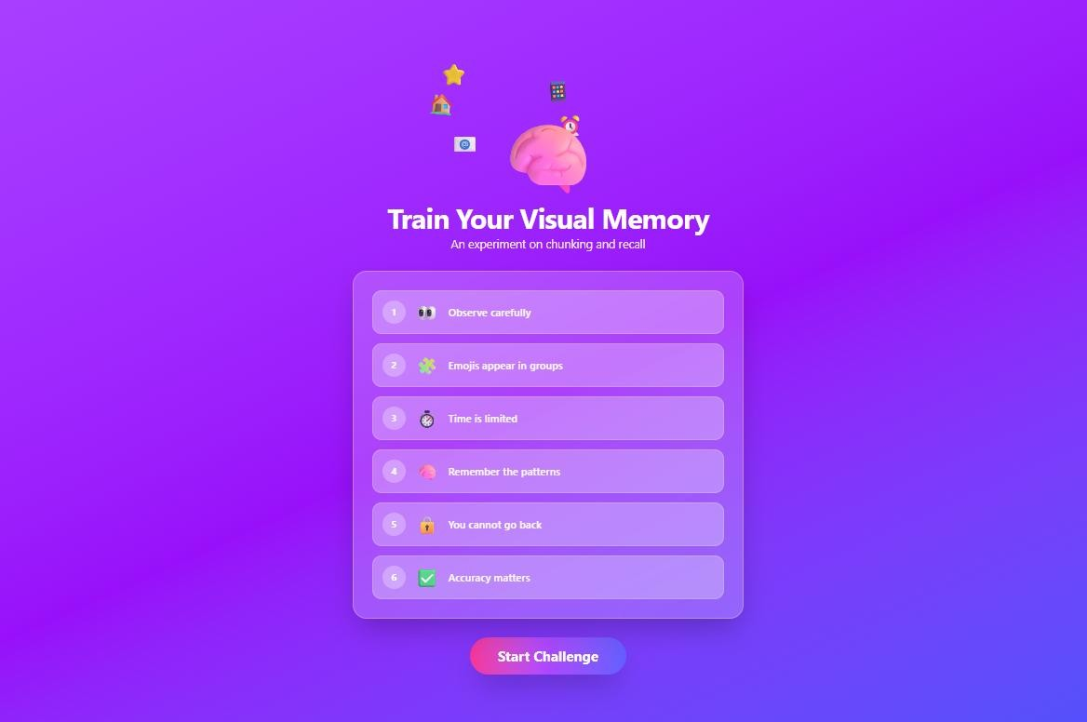

FRAME 2: CHUNKING PHASE

Analysis of the Memory Recall Task – Emoji Grouping Screen
This screen represents the Chunking Phase of the Memory Recall Task, where users are given a short time to observe and memorize emojis by organizing them into meaningful groups.

1. Purpose of the Screen
- This phase serves as the memory encoding stage.
- Users apply the chunking technique, which improves memory by organizing information into groups.
- Instead of memorizing individual emojis separately, users remember them group-wise, making recall easier and faster.

2. Key UI Elements and Components

Title – “Memorize the Emoji Groups”
- Clearly communicates the task objective.
- The eye icon indicates focus and observation.

Progress Bar
- Displays the remaining memorization time.
- The red progress indicator creates a sense of urgency.
- Helps users manage their time effectively during memorization.
Emoji Groups (Three Panels)
The emojis are organized into three groups, each containing four items:

Group A
- House
- Star
- Mobile Phone
- Email

Group B
- Car
- Alarm Clock
- Music Note
- Camera

Group C
- Apple
- Dog
- Moon
- Gift
This structure encourages:
- Category-based grouping
- Visual association
- Spatial memory (remembering by position)

Background Design
- A purple–blue gradient creates a modern and engaging interface.
- The clean layout reduces distractions and improves focus.

3. Working of the Chunking Phase
- Users observe the emoji groups and identify patterns within each group.
- The limited time encourages efficient memory strategies such as chunking.
- Once the time ends, the system moves to the Recall Phase, where users must identify or select the previously memorized emojis.

4. Cognitive and UX Benefits
- Improves short-term memory performance.
- Reduces cognitive load by organizing information into smaller groups.
- Enhances pattern recognition and spatial memory.
- Encourages active engagement and strategic thinking.
- Improves overall user experience through structured and visually clear design.
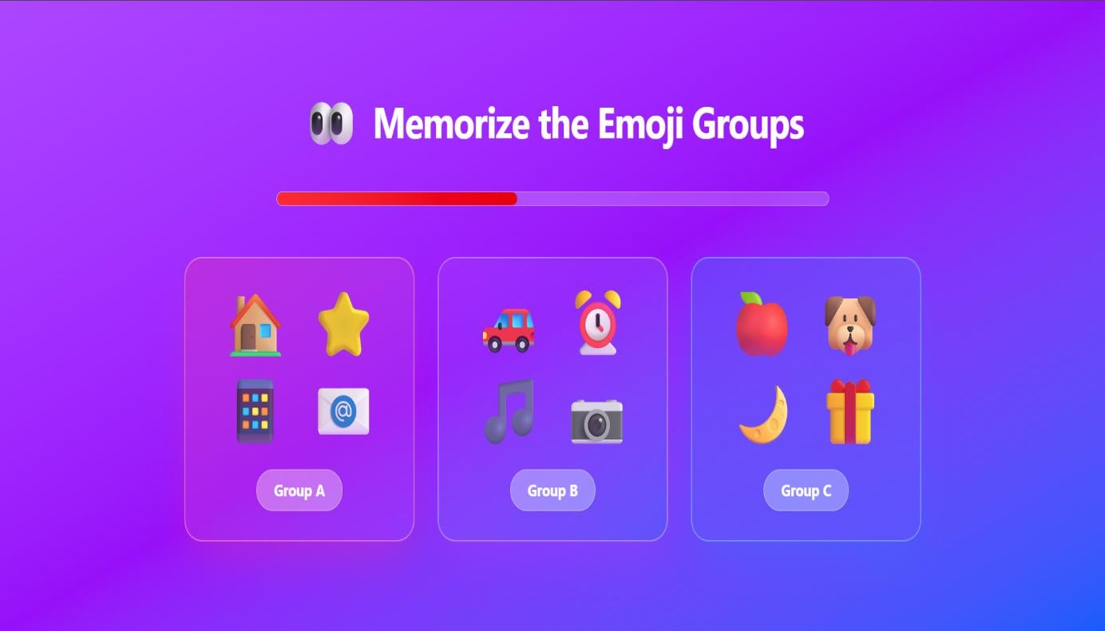

FRAME 3: RECALL PHASE

Analysis of the Memory Recall Task – Selection Phase
This screen represents the Recall (Selection) Phase of the Memory Recall Task, where users retrieve information stored during the Chunking Phase and identify the emojis they remember seeing earlier.

1. Purpose of the Screen
- This phase functions as the memory retrieval stage of the task.
- Users are required to recall and recognize emojis presented earlier, testing the effectiveness of chunking strategies.
- The screen evaluates short-term memory accuracy and resistance to false recall.

2. Key UI Elements and Components

Title and Instructions
- The title “Recall the Emojis” clearly communicates the task objective.
- Instruction text, “Select the emojis you remember seeing earlier”, provides simple and direct guidance, reducing user confusion.

Emoji Selection Grid
- A grid of emoji options is displayed, consisting of:
o Previously shown emojis (correct selections) o New distractor emojis (incorrect selections)
- This design tests the user’s ability to differentiate true memories from false ones.
- Each emoji is presented as a selectable tile, allowing users to click or tap to make their selections.

Selection Counter
- A selection indicator (e.g., “Selected: 12 emojis”) displays the number of emojis chosen.
- This helps users track their selections and make adjustments before final submission.

Submit Button
- The Submit button allows users to confirm their selections. • It is clearly visible and centrally positioned for easy access.
- Submitting leads to the results or feedback screen, where performance is evaluated.

3. Working of the Recall Phase
- Users review the emoji grid and mentally reference the Chunking Phase.
- They select the emojis they believe were shown earlier.
- Distractor emojis test recall accuracy and confidence.
- Upon clicking Submit, the system processes the selections and displays performance feedback.

4. Cognitive and UX Benefits
- Measures short-term memory strength and recall accuracy.
- Evaluates the effectiveness of chunking as a memory-enhancing strategy.
- Identifies false memory tendencies using distractor items.
- Simple selection mechanics reduce cognitive load.
- Clean layout, bright colors, and gamified visuals improve user engagement and motivation.
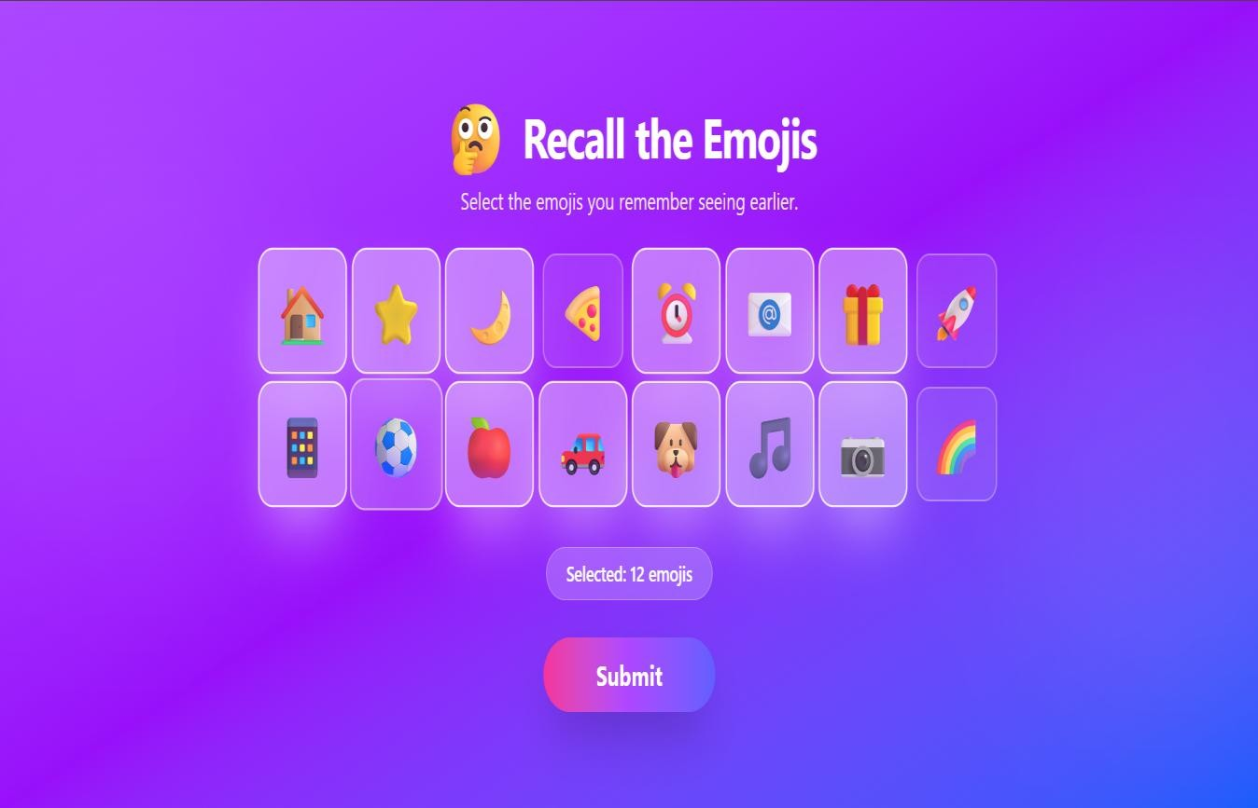

FRAME 4: RESULT PAGE

Analysis of the Memory Recall Task – Score & Feedback Screen
This screen represents the Score and Feedback Phase of the Memory Recall Task, where users receive a detailed evaluation of their memory performance based on their responses in the Recall Phase.

1. Purpose of the Screen
- To present the final recall performance in a clear and meaningful manner.
- To highlight the effectiveness of the chunking strategy used during memorization.
- To motivate users to reflect on their performance and retry the task for improvement.

2. Key Elements and UI Components

Title and Score Display
- The heading “Your Memory Score” clearly indicates the performance feedback section.
- A circular score indicator displays the result (e.g., 10 / 12), representing the number of correctly recalled emojis.
- The accuracy percentage (83%) is shown below the score, providing a precise measure of performance.
- The circular visual format allows users to quickly understand their results at a glance.

Brain Icon
- Represents memory and cognitive processing.
- Reinforces the educational and cognitive training purpose of the application.

Feedback Message
- A message such as “Chunked emoji groups improved your recall accuracy” explains the reason behind the performance.
- Helps users understand the effectiveness of the chunking technique rather than just viewing the score.

Effect of Chunking Indicator
- A horizontal progress bar displays “Effect of Chunking – 75%”.
- Visually demonstrates how much the chunking strategy contributed to memory performance.
- Encourages users to continue using grouping techniques for better recall.

Action Button
- The “Try Again” button allows users to repeat the task.
- Supports continuous learning and performance improvement through practice.

3. How This Phase Works
- The system compares the emojis selected during the Recall Phase with the original set.
- Correct responses are counted to calculate the final score and accuracy percentage.
- The system estimates the impact of chunking on recall performance.
- Results are presented using numerical, textual, and visual feedback.

4. Cognitive and UX Benefits
- Immediate feedback improves learning and memory awareness.
- Encourages metacognition, allowing users to evaluate their memory strategies.
- Visual indicators reduce cognitive effort in interpreting performance.
- The retry option promotes practice-based improvement in a low-pressure environment.
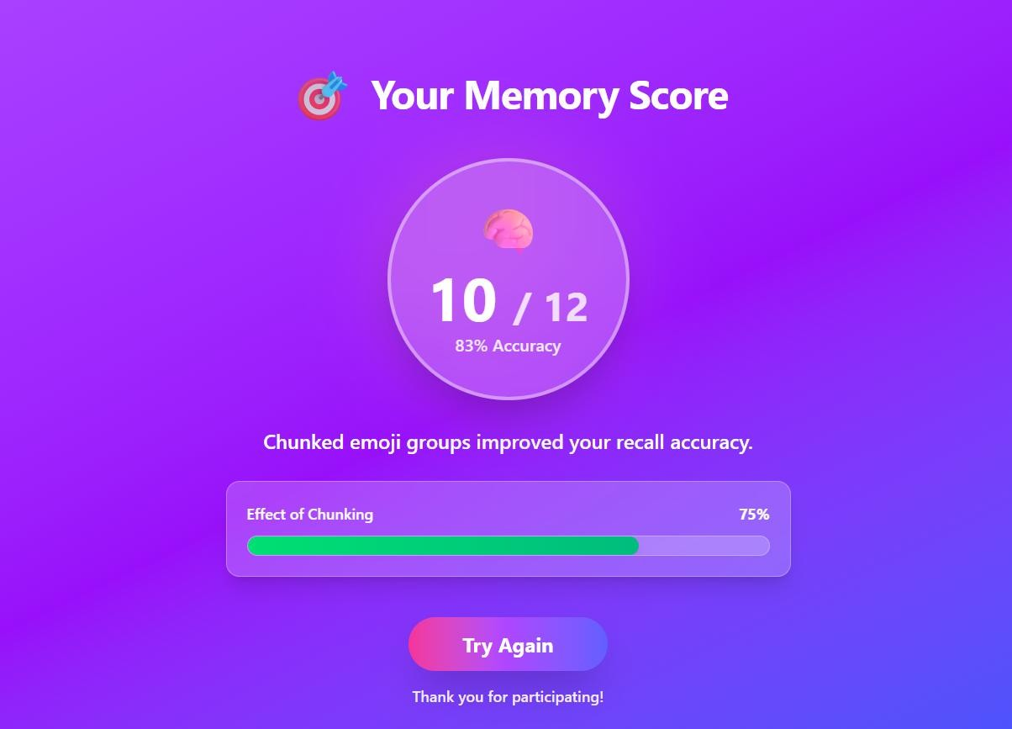
PROTOTYPE LINK:
https://bell-stack-94786222.figma.site/

